# **Technical Report 1**

Python code to match histograms of two images with different content and background colours.

import cv2 as cv

import numpy as np

import matplotlib.pyplot as plt

import matplotlib.cm as cm

from PIL import Image as pimg

from skimage import data

from skimage import exposure

from skimage.exposure import match_histograms

img1 = plt.imread(r"C:\Users\manub\Desktop\test.1.jpeg")

img2 = plt.imread(r"C:\Users\manub\Desktop\test.4.jpeg")

channel_axis = 1

def df(img, deb=""):

values = np.zeros((256))

for i in range(img.shape[0]):

for j in range(img.shape[1]):

values[round(img[i,j])]+=1

return values

def cdf(hist):

cdf = np.zeros((256))

cdf[0] = hist[0]

for i in range(1, len(hist)):

cdf[i]= cdf[i-1]+hist[i]

cdf = [ele*255/cdf[-1] for ele in cdf]

return cdf

plt.figure(0)

plt.title('Input image')

plt.imshow(img1, cmap=cm.gray, vmin=0, vmax=256)

plt.figure(0)

plt.title('Input image')

plt.imshow(img2, cmap=cm.gray, vmin=0, vmax=256)

plt.figure(1)

plt.title('Histogram of default image')

plt.hist(img1.flatten(), bins=256, range=(0, 250))

plt.figure(1)

plt.title('Histogram of default image')

plt.hist(img2.flatten(), bins=256, range=(0, 250))

matched = match_histograms(img1, img2, multichannel=True)

fig, (ax1, ax2, ax3) = plt.subplots(nrows=1, ncols=3, figsize=(8, 3),

sharex=True, sharey=True)

for aa in (ax1, ax2, ax3):

aa.set_axis_off()

ax1.imshow(img1)

ax1.set_title('Source')

ax2.imshow(img2)

ax2.set_title('Reference')

ax3.imshow(matched)

ax3.set_title('Matched')

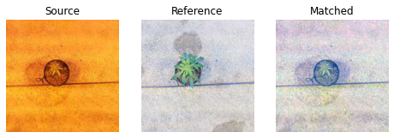

plt.figure(1)

plt.title('Histogram of default image')

plt.hist(matched.flatten(), bins=256, range=(0, 250))

Histogram of Image with orange background and white background respectively.

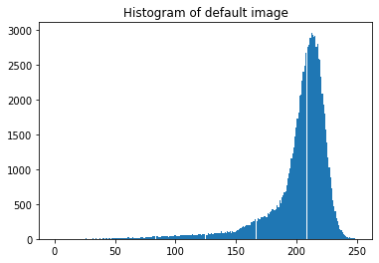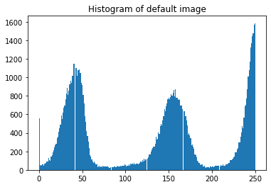

Matched histogram

